**Cloud Security - Final Project (Write Up Form)**

Requires an AWS account to perform the listed requirements:

* AWS Services:
  + Amazon Lex (including Analytics)
  + Lambda
  + Simple Notification Service (SNS)
  + CloudWatch

**Amazon Lex:**

This chatbot was created with the intention of having an interactive conversation through text.. I had to create a bot,add my intents, and include my custom slots with my intents to represent an action based on what the user wants to perform.

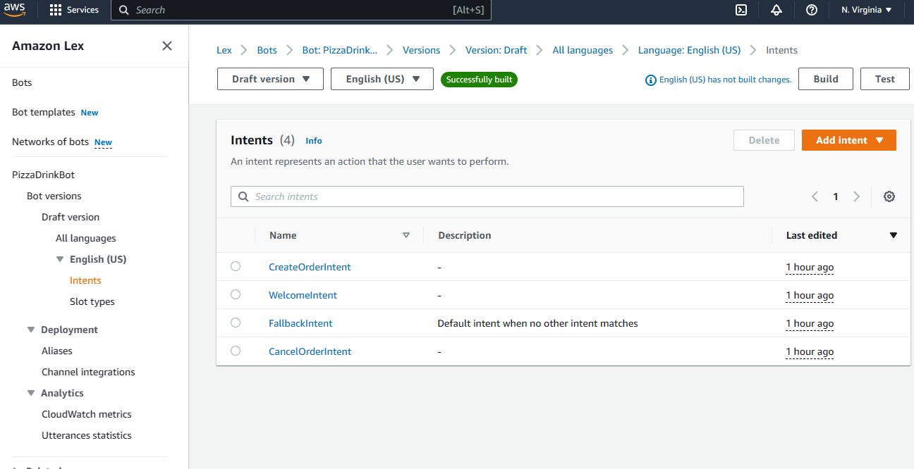

Here is an example of the chatbot conversation for ordering a pizza with a drink:

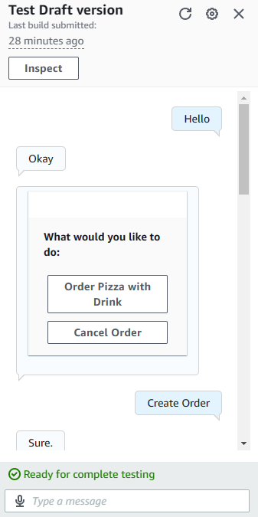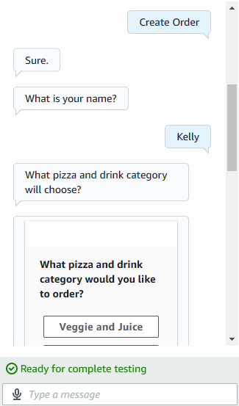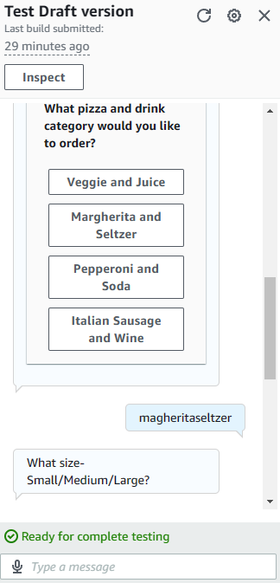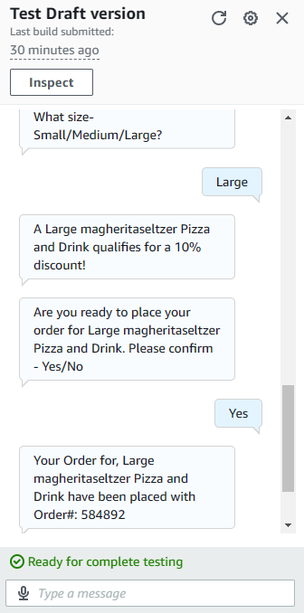

You can also view the analytics of these conversations in CloudWatch metrics (i.e. graphs) and Utterances statistics (i.e. missed and detected) under Amazon Lex.

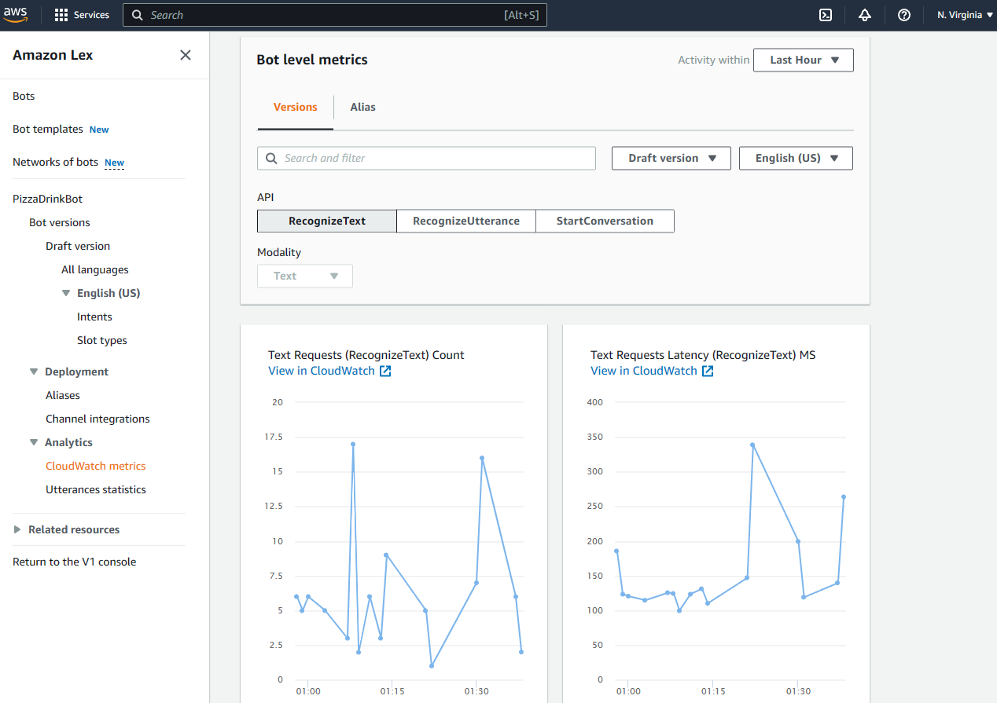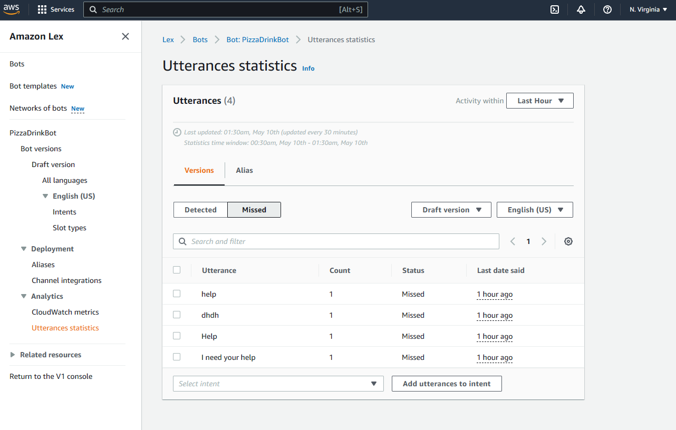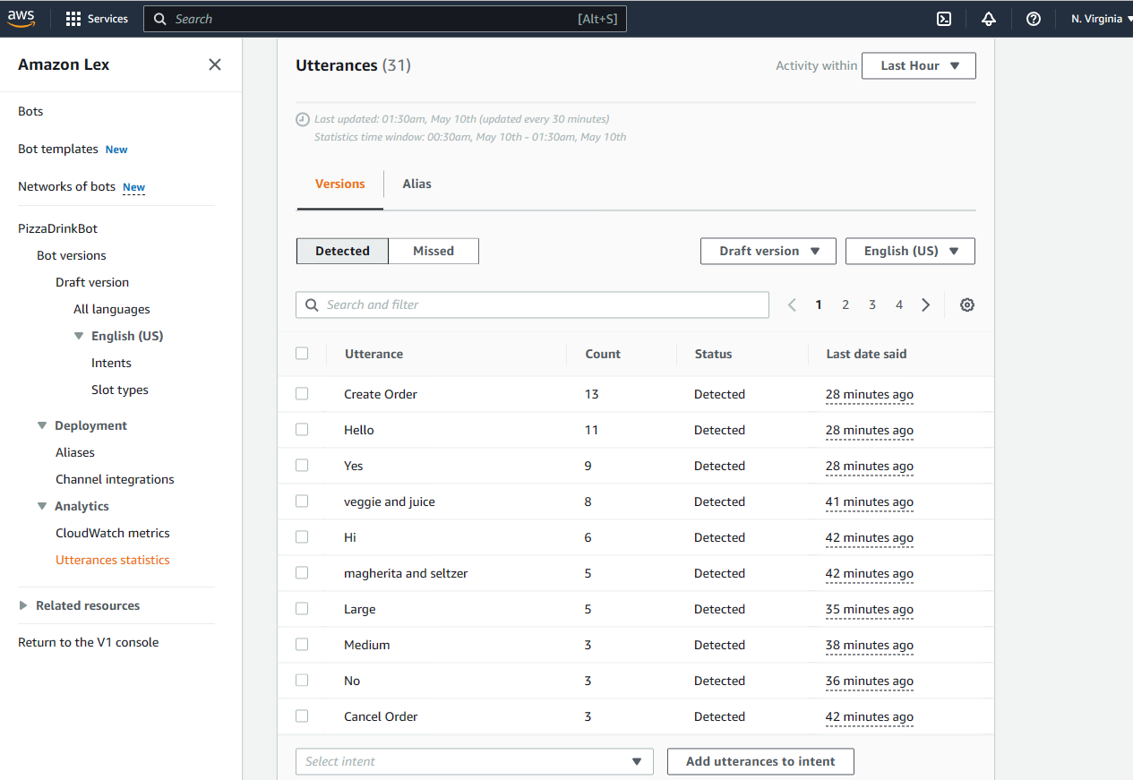

**Lambda and SNS:**

This chatbot was also integrated with Lambda and SNS to retrieve messages and track occurrences.After creating the lambda function and SNS, I copied the Function Arn from the lambda function to the SNS for me to test the updated chatbot. Once I deployed the code changes using Python in the lambda function, I created an Alias under Amazon Lex to invoke its use with the lambda function as a source. Warning: The chatbot fulfillment needs to check that you’re using a lambda function for the chatbot to work or an error will be thrown.

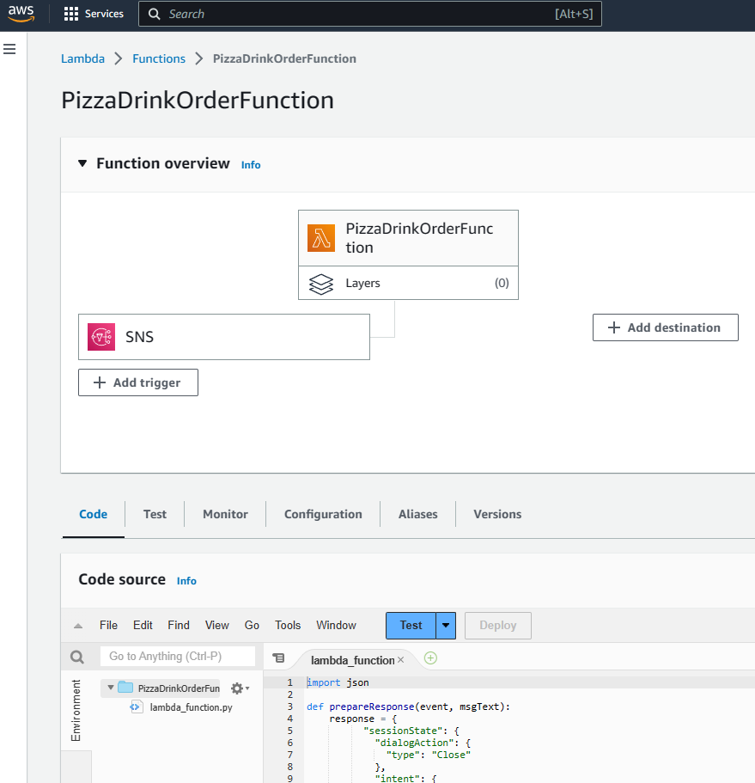

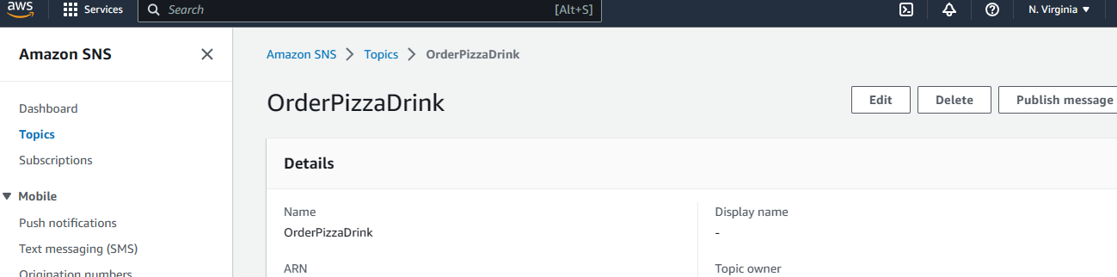

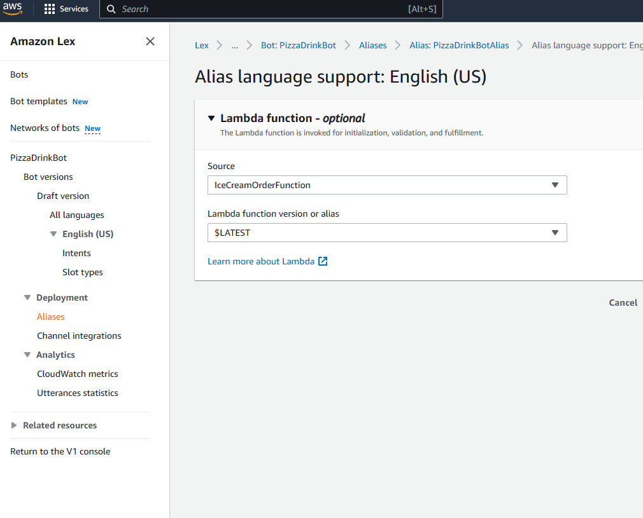

**CloudWatch:**

You can view the chatbots integration of your lambda function with SNS and Cloudwatch by going to Monitor > Logs > View CloudWatch logs to view the timestamp and message.

